**WENTWORTH LOCAL ENVIRONMENTAL PLAN 2011**

**PLANNING PROPOSAL REPORT**

**ENVIRONMENTAL PLANNING & ASSESSMENT ACT 1979 – S56 GATEWAY DETERMINATION**

**Sturt Highway, Trentham Cliffs**

**August 2015**

**Table of Contents**

1. Introduction................................................................................................................................
   1. The Planning Proposal...................................................................................................
   2. Site and Locality............................................................................................................
2. Objectives or Intended Outcome...............................................................................................
3. Explanation of the Provisions.....................................................................................................
4. Justification................................................................................................................................
   1. Need for the Planning Proposal....................................................................................
   2. Strategic Planning Framework......................................................................................
      1. Wentworth Region Community Strategic Plan 2013-2023.............................
      2. Wentworth Shire Council Economic Development Strategy 2011-2016.........
      3. The Regional Development Australia Murray Regional Plan 2013-2016..........
      4. Economic Development Strategy for Regional NSW January 2015.................
   3. Environmental, Social & Economic Impact...................................................................
      1. Environmental Impact.....................................................................................
      2. Social Impact...................................................................................................
      3. Economic Impact.............................................................................................
      4. State and Commonwealth..............................................................................
5. Community Consultation..........................................................................................................
6. Proposed Project Timeframe....................................................................................................

**Attachments**

1. Draft Development Concept Plan
2. Aerial Photo
3. Current Land Zone Map
4. Additional Permitted Uses Map
5. Consistency with S.117 Ministerial Directions and State Environmental Planning Policies Table
6. Council Report and Resolution from Ordinary Council Meeting 18 March 2015
7. **INTRODUCTION**

**1.1 The Planning Proposal**

This planning proposal is seeking an amendment to the Wentworth Local Environmental Plan 2011 to provide permissibility for the development of a Highway Service Centre and a Caravan/RV Park at Trentham Cliffs.

The proposed development of the Highway Service Centre will include the sale of fuel and diesel, with a separate canopy for heavy vehicles, convenience goods, restaurant, shower/change rooms and truck parking at the rear of the establishment. Access to the site will be from the Sturt Highway and will be designed to ensure safe entry and exit and is expected to require road widening and turning lanes.

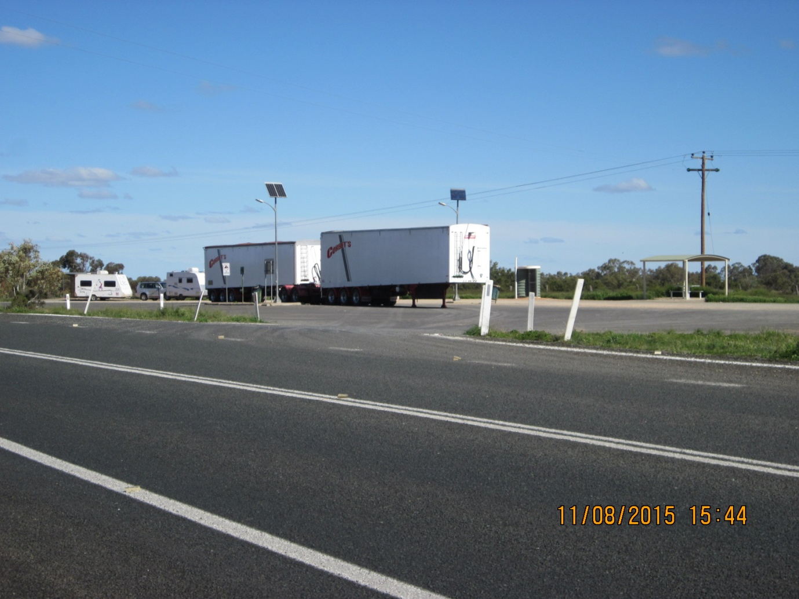

Photo 1 – Existing Trentham Cliffs Rest Stop

The Caravan/RV Park aims to provide a facility that has the functionality to cater for the growing RV market and the subsequently for facilities to be designed to enable appropriate access and parking arrangements for the larger vehicles. Additionally, the development will provide a recreational area and storage facility for patrons.

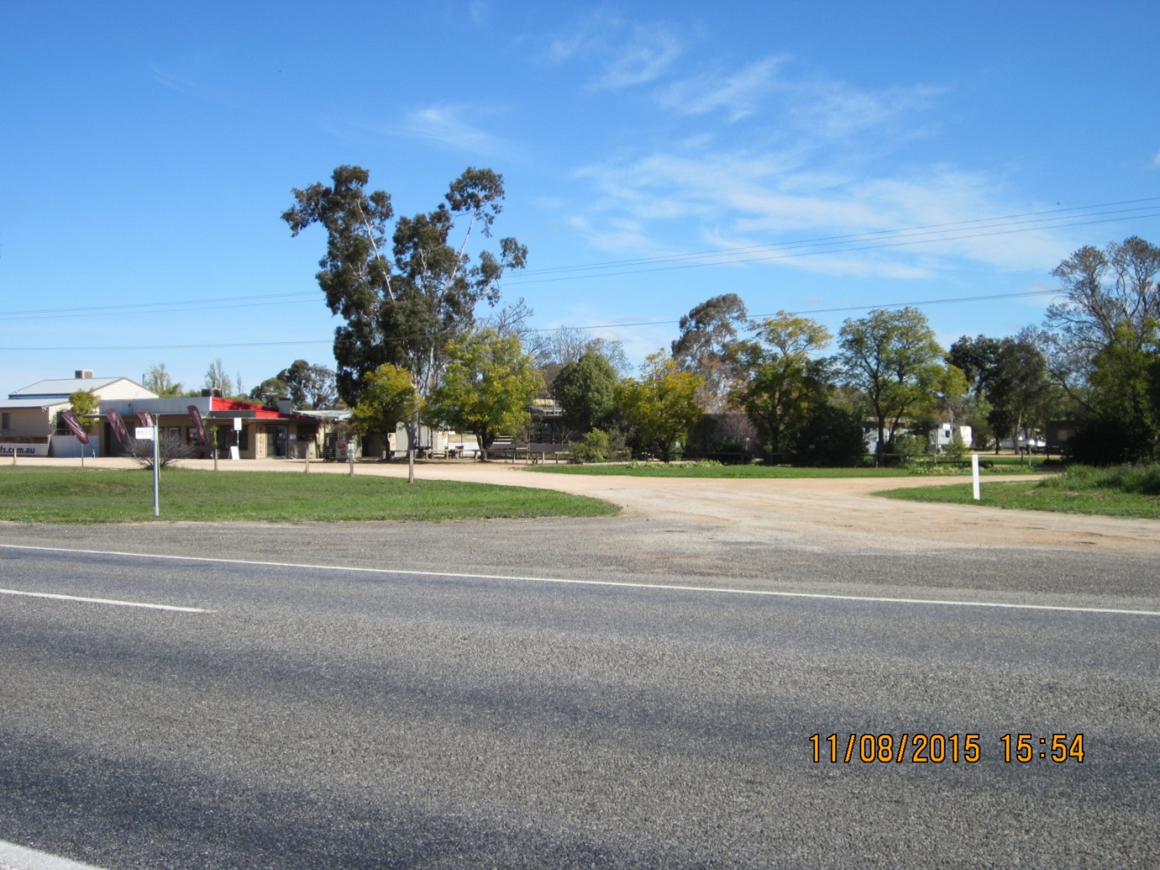

Photo 2 – Existing Trentham Cliffs Caravan Park

The Caravan/RV Park will also take advantage of the low lying, riverfront parcel of land to the west. This land provides significant opportunities for nature based tourism and recreational pursuits including walking, swimming, boating and passive enjoyment of the environment.

The riverfront parcel of land is considered essential to the overall success of the development. The area will be used for active and passive recreational activities on water and land. It will be necessary to remove weeds, rubbish and exotic vegetation to allow for the replanting of local native vegetation. In addition, improvements may include a boat ramp, casual mooring areas, jetties, BBQ areas, shelters, tracks and walking paths etc.

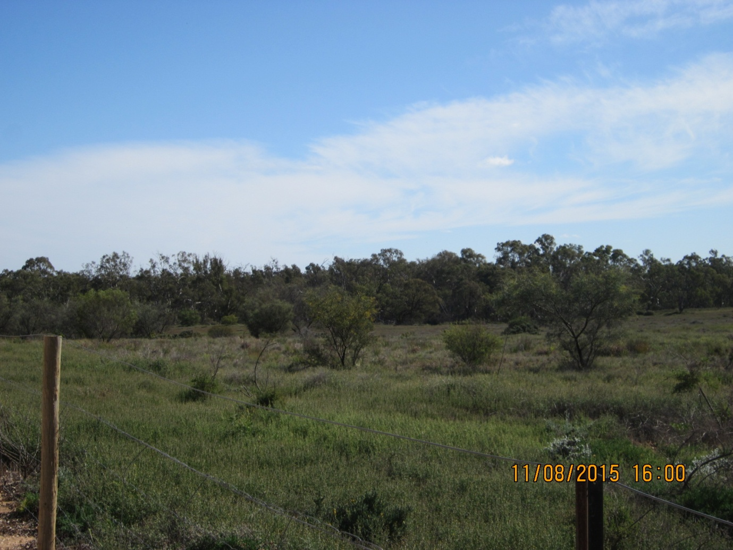

Photo 3 – Looking West over proposed RV Park site to the Wetlands

Refer to Attachment 1 – Draft Development Concept Plan.

**1.2 Site and Locality**

|  |  |  |  |
| --- | --- | --- | --- |
| Land | Zone | Current Use | Proposed Use |
| Lot 1 DP1128099 | Part R5 Large Lot Residential and part RU1 Primary Production | Dryland farming | Caravan/RV Park |
| Lot 38 DP756936 | R5 Large Lot Residential | Caravan Park | Highway Service Centre |
| Lot 42 DP756936 | R5 Large Lot Residential | Dryland farming | Part of Highway Service Centre and Caravan/RV Park |
| Lot 1 DP1197180 | RU1 Primary Production | Native wetlands | Passive riverfront recreational use |

The property to the north has previously been used for horticulture but does not appear to be used at present. The site to the east, directly opposite the existing rest stop (across the Sturt Highway), currently contains a habitable dwelling and associated outbuildings for dry land farming purposes.

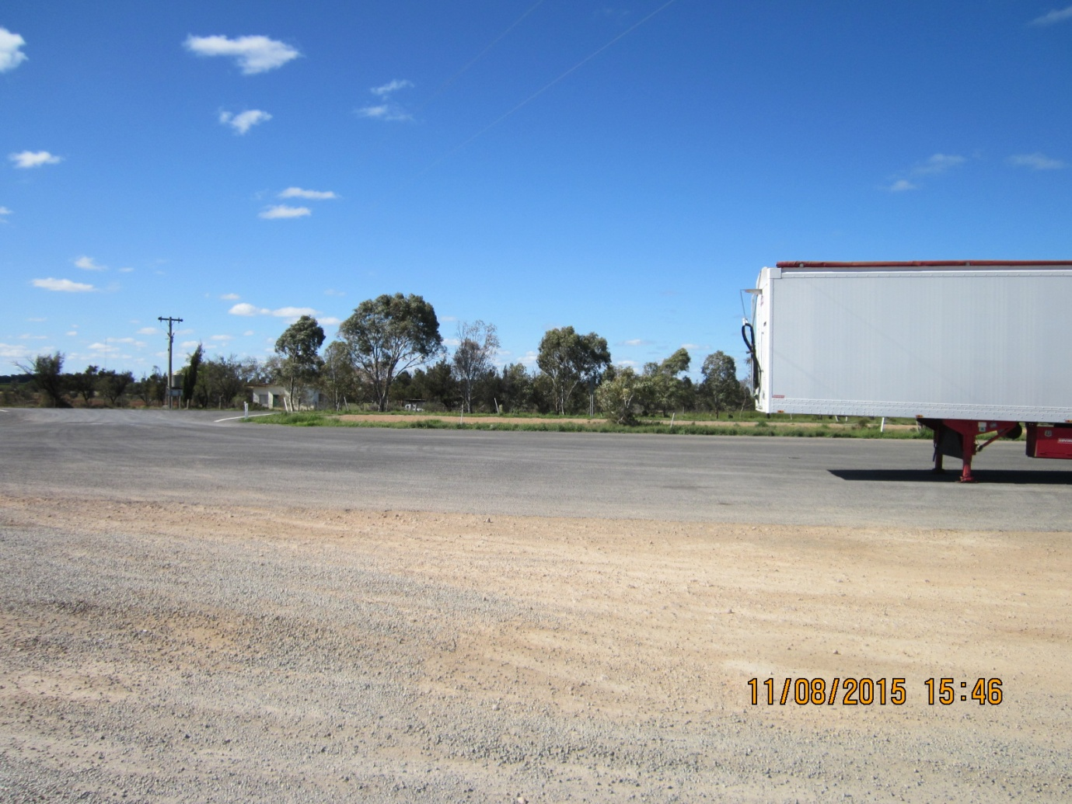

Photo 4 – Dwelling East of existing Trentham Cliffs Rest Stop (across the Sturt Highway)

To the south of the subject lots the property is actively used for horticultural purposes with an agricultural shed situated on the northern boundary and a dwelling located centrally on the site.

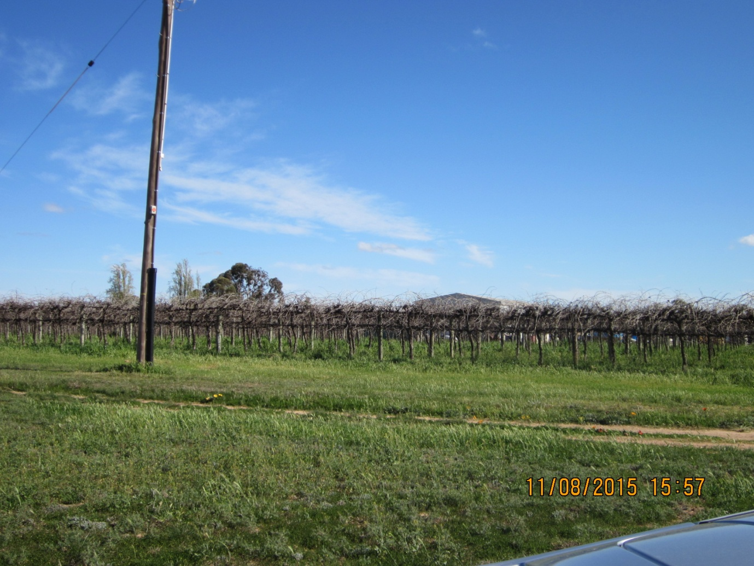

Photo 5 – Adjoining property on South boundary

The Trentham Estate Winery is located approximately 500 metres south of the southern boundary, the proposed Highway Service Centre south boundary.

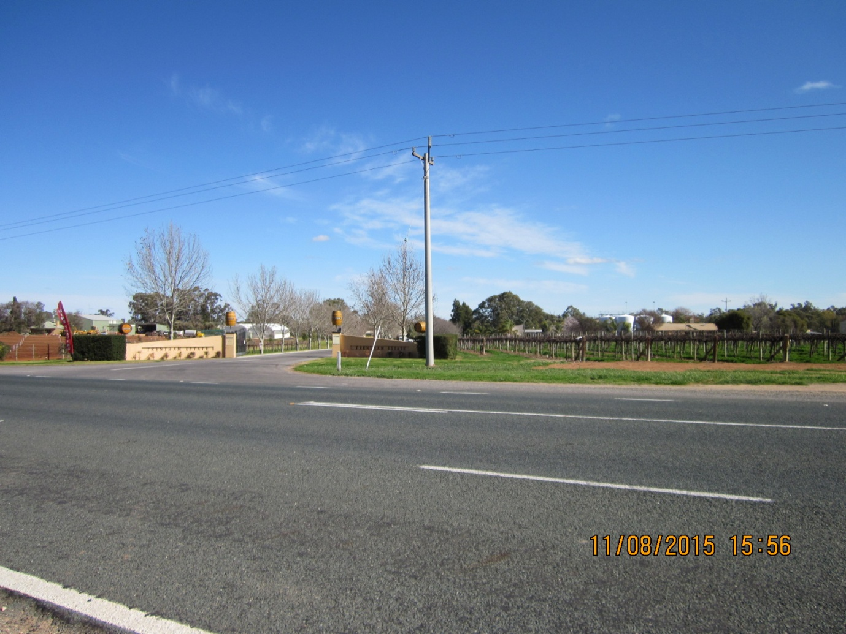

Photo 6 – Trentham Estate Winery approximately 500 metres from South boundary

Refer to Attachment 2 – Aerial Map.

1. **OBJECTIVES OR INTENDED OUTCOMES**

The objectives and intended outcomes of the planning proposal are to:

* To facilitate the development of a Highway Service Centre,
* To facilitate the development of a Caravan/RV Park,
* Support the success of a Highway Service Centre and Caravan/RV Park by utilising the wetlands area to the west with nature based tourism and passive recreational pursuits, and
* Amend the Wentworth LEP 2011 to permit the development of the site for the purposes of a Highway Service Centre and Caravan/RV Park.

1. **EXPLANATION OF THE PROVISIONS**

The proposed outcome will be achieved through amending the Wentworth LEP 2011 Schedule 1 Additional Permitted Uses and introducing an Additional Permitted Uses Map, as described below:

**7 Use of certain land at Sturt Highway, Trentham Cliffs**

1. This clause applies to Lot 38 DP756936 and part of Lot 42 DP756936 at Sturt Highway, Trentham Cliffs and identified as “Area B” on the Additional Permitted Uses Map.
2. Development for the purposes of a Highway Service Centre is permitted with development consent.

**8 Use of certain land at Sturt Highway, Trentham Cliffs**

1. This clause applies to part of Lot 1 DP1128099 at Sturt Highway, Trentham Cliffs and identified as “Area C” on the Additional Permitted Uses Map.
2. Development for the purposes of a Caravan/RV Park is permitted with development consent.
3. **JUSTIFICATION**

**4.1 Need for the Planning Proposal**

The current zones applied to the subject site are R5 Large Lot Residential zone and RU1 Primary Production zone.

These zones are applied to the land as follows:

* Lot 1 DP1128099, Sturt Highway, Trentham Cliffs – R5 Large Lot Residential and RU1 Primary Production zone – proposed part of site for Caravan/RV Park.
* Lot 42 DP756936, Sturt Highway, Trentham Cliffs – R5 Large Lot Residential zone – proposed part of site for Highway Service Centre and part of site for Caravan/RV Park.
* Lot 38 DP756936, Sturt Highway, Trentham Cliffs – R5 Large Lot Residential zone – proposed site for Highway Service Centre.
* Lot 1 DP1197180, Sturt Highway, Trentham Cliffs – RU1 Primary Production zone.

Refer to Attachment 3 – Current Land Zoning Map.

In accordance with the provisions of these zones:

* R5 Large Lot Residential zone permits with consent the development of a Caravan Park and prohibits the development of a Highway Service Centre.
* RU1 Primary Production zone prohibits the development of a Caravan Park and a Highway Service Centre.

The planning proposal is not a consequence of a related strategy or study.

In terms of obtaining permissibility for the development proposal, an alternative zone was investigated. SP3 Tourist zone was considered for the site due to the permissibility with consent of a range of tourism uses including Highway Service Centre, Camping Grounds and Caravan Parks. Although it may appear that this zone would be appropriate for the site, consideration of surrounding land uses and the area to be rezoned was also undertaken.

The property abutting the south boundary of the proposed Highway Service Centre is currently used for horticulture, despite being partially zoned as R5 Large Lot Residential. Further to the south is the Trentham Winery Estate which includes cellar door sales and a restaurant. Originally, it was thought that rezoning the entire area to SP3 Tourist zone would be appropriate and would facilitate the development of the area as a small tourism precinct, justified and supported by the level of activity and patronage that is experienced by the winery.

However, prior to proceeding with proposing to rezone the area to SP3 Tourist zone, further consideration and investigation of the existing use of the land between the subject site and the winery with the current land owners needs to be undertaken. The extent of the additional uses permitted in the SP3 Tourist zone and the impact on surrounding agriculture/horticulture is also required, together with an analysis of the demand for SP3 Tourism zoned land in Trentham Cliffs.

It is therefore considered that by amending the Wentworth LEP 2011 Schedule 1 Additional Permitted Uses and introducing an additional permitted uses map to allow for the use of the site as a Highway Service Centre and Caravan/RV Park, is the most efficient and effective process of facilitating the development of the site, while ensuring the existing surrounding uses are protected by retaining the current zones applied to the land.

Refer to Attachment 4 – Proposed Additional Permitted Uses Map.

* 1. **Strategic Planning Framework**

The planning proposal is consistent with the aims and objectives of the following strategic documents that are relevant to Wentworth Shire Council and its community:

*4.2.1 Wentworth Region Community Strategic Plan 2013-2023*

The Wentworth Region Community Strategic Plan reveals that the Wentworth Shire community want to be vibrant, growing and thriving by supporting a strong tourism industry, encouraging investment in business/industries, reducing red tape that restricts development and expanding employment opportunities.

The proposal is consistent with the vision outlined in the Community Strategic Plan by facilitating the development of and investment in the tourism industry and business, using the most efficient process to allow the development to proceed and will provide employment opportunities during the construction and operational phase of the development.

*4.2.2 Wentworth Shire Council Economic Development Strategy 2011-2016*

One of the strategies of the Economic Development Strategy is to promote the region and support the growth of tourism.

The planning proposal is consistent with the strategy as it seeks to provide an opportunity for a local landowner to develop a new Caravan/RV Park that will cater for the growing number of large vans and RVs touring around the country, including the Sunraysia region and provide accommodation for tourists with a rural, Murray River experience.

The strategy supports the growth of small business, of which this planning proposal seeks to achieve permissibility for two additional commercial enterprises.

The proposal will also provide a net community benefit through ongoing employment opportunities in the retail and building trades, both during the construction and operational phase.

*4.2.3 The Regional Development Australia Murray Regional Plan 2013-2016*

The RDA Murray Regional Plan states that ‘*There are obvious sub-regional distinctions between various economic activities. The Western part of the region has a strong emphasis on fruit, nut, vegetable and wine production’* and ‘*A significant proportion of visitor expenditure is likely to be spent on retail, accommodation and food service businesses, thus boosting these small scale businesses in the region.’*

Located in the south west corner of New South Wales, economic drivers for the Sunraysia region are irrigated horticulture, dry land agriculture and tourism driven by the popularity of the Murray River and the mild Mediterranean climate.

The planning proposal is consistent with this plan as it seeks to expand and improve the existing caravan and cabin facilities which will inevitably contribute to and compete with the range of accommodation currently provided on both sides of the Murray River.

The proposal will also service the constant and growing number of road users of the Sturt Highway by providing a safe, convenient and serviceable rest stop for both large and small vehicles.

*4.2.4 Economic Development Strategy for Regional NSW January 2015*

The Strategy identifies five goals to enable economic growth:

·         Promote key regional sectors and regional competitiveness

·         Drive regional employment and regional business growth

·         Invest in economic infrastructure and connectivity

·         Maximise government efficiency and enhance regional governance

·         Improve information sharing and build the evidence base

The planning proposal is consistent with this strategy as it will provide local employment opportunities and business growth in the municipality, while catering for the growing number of tourists, both on and off the road.

Refer to Attachment 5 – Consistency with applicable S.117 Ministerial Directions and State Environmental Planning Policies.

* 1. **Environmental, Social & Economic Impact**

*4.3.1 Environmental Impact*

The development site does not contain any critical habitat or native vegetation of significant biodiversity value that would be under threat as a result of the development of the subject site.

The proposed development will not have any detrimental impact on the area of land between the site and the Murray River that is subject to the Wentworth LEP 2011 Terrestrial biodiversity and Wetlands mapping. To ensure its protection, the development will provide reticulated water sewerage infrastructure to ensure that the nature reserve is protected from any risk of contamination from waste.

The proposal plans to integrate the low lying wetlands site adjoining the Murray by providing recreational activities on this parcel of land. The passive use of this site will not have a detrimental impact on the natural environment or significant of the land. The proposal will however, remove any introduced and exotic weeds that have established and will be replaced by local native vegetation.

The future Development Application would be required to address in detail:

* The buildings to be constructed on site
* Access to the Sturt Highway, including traffic and parking
* Noise
* Storage of fuel
* Provision of waste, power and water
* Security of development site.

*4.3.2 Social Impact*

The proposed Highway Service Centre will provide greater consumer choice for fuel and convenience food, a safe rest spot for travellers in an ‘out of town’, quiet location, with ample space for general parking and heavy vehicle transport. All highway traffic will have the ability to rest, purchase and consume food and drinks on site.

The proposed Caravan/RV Park aims to provide facilities for the growing caravan and RV market. Many of the mature aged travellers who dominate this tourism sector choose to travel in groups, therefore, the provision of adequate facilities to cater for the growing number and size of these vehicles is paramount to support the current and future market.

The proposal will provide recreational pursuits that will also attract young people and families with the integration of the use of the wetlands and Murray River frontage.

The Caravan/RV Park will also provide the opportunity for visitors to enjoy local, quality accommodation in a rural environment, experience the locally produced wine and quality meals at the nearby winery and enjoy the recreational activities provided by the park and the Murray River.

*4.3.3 Economic Impact*

The integration of three components associated with the proposed development will complement and support one another.

The highway service centre will provide food, beverages and fuel for those travellers who choose to stay at the Caravan/RV Park.

The Caravan/RV Park provides a convenient location for an overnight or extended stopover for tourists travelling through the area who will have the convenience of an out of town service and food centre.

Statistics provided by the Campervan Motorhome Club of Australia include:

* It is estimated that the number of RV travellers will increase by more than 60% over the next 10 years
* The market is worth $6.5 billion a year to the Australian economy
* The biggest spending travellers spend an average of $500 to $900 per week
* RV travellers spend patterns are more like residents in that they spend directly into the community, for day-to-day needs, purchasing tourism services and products as it suits
* Preferred activities include visiting markets, heritage sites and museums, bushwalking, visiting National Parks and undertaking full or half day tours

[**http://www.segra.com.au/segra13ConfProc/presentations/Day3-RVFuturesForum-GrowthAndValue.pdf**](http://www.segra.com.au/segra13ConfProc/presentations/Day3-RVFuturesForum-GrowthAndValue.pdf)

Already a successful and popular enterprise, the nearby Trentham Estate Winery may experience an increase in patronage generated by visitors staying at the Caravan/RV Park or those utilising the Highway Service Centre.

The proposal will provide for temporary employment during the construction phase of the development and ongoing employment opportunities thereafter through the operation and maintenance of the Caravan/RV Park and Highway Service Centre.

The development, if commercially successful, may provide the opportunity and a stepping stone for the future establishment of a ‘tourism’ precinct for the area.

1. **COMMUNITY CONSULTATION**

Pursuant to Section 56(2)(c) and 57 of the Environmental Planning and Assessment Act 1979 exhibition of the planning proposal will be conducted over a 28 day period as follows:

* Public notice in the Mildura Weekly newspaper, and
* Advertised on the Wentworth Shire Council website, and
* Written public notice to the following State Agencies –
  + Murray Catchment Management Authority
  + NSW Office of Water
  + Essential Energy
  + Office of Environment & Heritage
  + Roads and Maritime Services

The following information will be made available for inspection:

* The Gateway Determination
* The planning proposal documentation
* Site locality and aerial maps

Community consultation will be complete when Wentworth Shire Council has appropriately and effectively considered all submissions received relative to the planning proposal.

1. **PROPOSED PROJECT TIMELINE**

This project timeline provides a mechanism to monitor the progress of the planning proposal:

|  |  |
| --- | --- |
| Gateway Determination | September 2015 |
| Community Consultation, incl State Agencies | October 2015 |
| Consideration of submissions | November 2015 |
| Consideration of a proposal post exhibition | December 2015 |
| RPA Adoption to make Plan | January 2015 |
| Submission to DP&E & PCO to finalise LEP | February 2015 |
| Forward to Department for notification | March 2015 |